**The trolley problem**

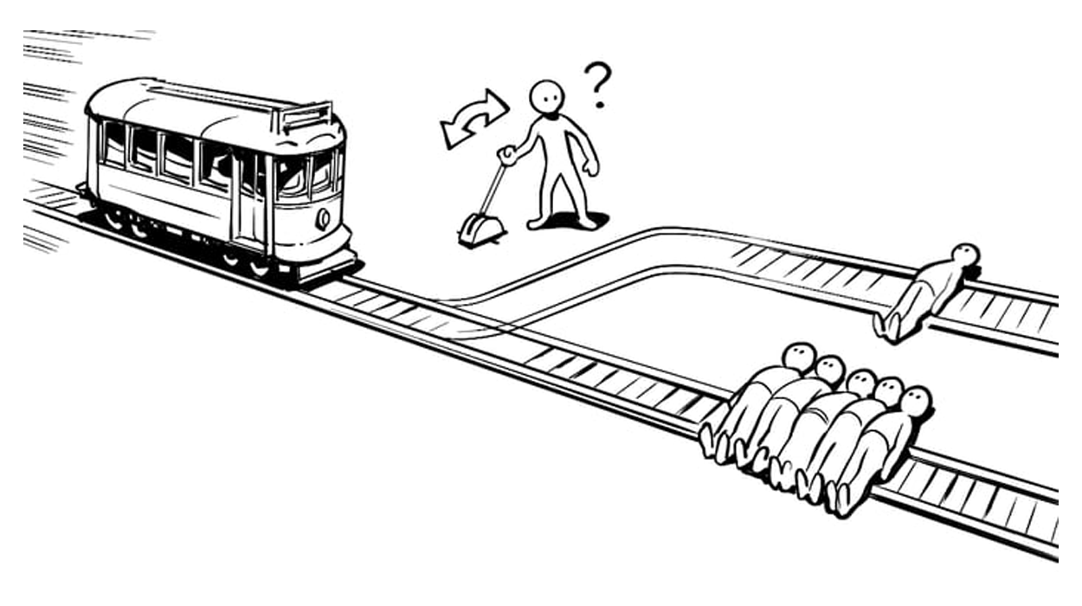

Nothing special, benchmark to discuss different theories.

Trolley keep going straight ahead on the track. If nothing is done it will kill 5 people. Trolley can also go on a different track. On the other track there is only one person that will be kill if the trolley change direction. You need to decide in which direction it will go

You have a switch

* do nothing ⟹ kill 5 innocent people
* pull the switch ⟹ kill 1 innocent person. Directly killed by you

Comparison between the values of life. Better 5 alive rather than just 1. Your action and omiction have consequences, you are guilty in any case even if you do or do not any action.

**Action and omiction**. What *should* you do. What is the morally right thing to do?

*Will you pull the lever or not?* is not an ethical question. *What should you do?* instead is an ethical question.

**Ethics**: what one should do. How to behave correctly.

Ethics ≠ instrumental obligation. Tells what you have to do if you want to reach a particular situation.

First big distinction. Moral obligation and insturmental obligation

Ethics is what you should do, all things consider.

**Ethics vs morality**. We will use both words interchangeably. Etymologically speaching they come from different rooths but with similar meanings (habit, consuetudine).

What is the right moment to enter a politic career?...

In the history of philosophy(?) have been use in different ways. Society level more important than individual level (for some thinkers)

While our modern/conteporary wester society is build on the idea that the state and the other values (religion,...) have somehow being separate. While on paper/in spirit there is a distioncton between law and ethics there are some exchange. Ethics is what you should be doing all things consider. Something you have other obligation.

Compulsory military service. You are drafted, need to serve for 1/2/3 years. Many country used to have obiezione di coscienza (conscientious objection). You oppose to handing weapons and you do something else.

Or in abortion if you are a doctor. For religious ground in some country (Italy for example) doctors are allowed to not perform abortion.

Permission: **obbligation ≠ permittion. Must and may**. Obbligation you must do it, permission depends on you.

**Supererogatory** task. Donate all my money for charity, is good if I do it, but is not obligatory. Something that is good and allowed, but is not obligatory.

**Descriptive ethics and normative ethics**

Trolley problem: one question is *what people do* and *what you do* and also *what people should do* and *what you should do*

Different people have different theories and different answers

Back 2000 years in the roman empire. Most people where ok with owning slaves (vast majority if they could they would own slaves). Can we concude that slavery was right? If the majority determine what is correct ⟹ slavery is morally correct. Regardless of what people do there is a separate question *is slavery right?*. How values change. Values change over time so also what is morally change over time. Other point of view states that moral is choosed by God.

Even if most people would still do something that does not necessary have an influence of what people should do. If most people's intuition is to pull the lever we can still keep separate a descriptive investigation from a normaty standpoint. What you will do vs what you should do.

Most people don’t have a moraly theory to follow. In concrete situation different behaviour. Among the descriptive ethics there is an evolutionary approach. Altruithism or cooperation w/out benehthis, kindness… How did it happens? why it is resulted in the same way? **Evolutionary investigation** done by biologist. It would be a mistake to conclude that what happened in nature is what we should be doing.

In most animal species disable individual/edlery/weak are left to die. From this conclude that we should push out disable individuals.

What should one do? Normative ethics have 3 subfield

* **First orderd moral theory**: what you should do in general. You should/should not pull the lever. Gives us the content. 4 main subset.
  + ontology
  + consequentialism
  + virtue ethics
  + particularism
* **Meta-ethics**: is the second order moral theory. Is the investigation on ethics. investigate in three level
  + logical semantical: what *should* and *may* means? what is obligation? question on ethics
  + epistemology: how do we know ethical knoledge? is rational, it does exist?
  + ontological/metaphysical. Do ethical values exist? are they in the word or are they subseject construction of our indivudal mind
* **Applied ethics**: for bioethics. Is abortion right? for professional ethics: works conduction. Business ethics and they ethics of AI. How do I given my ethical theory, how do I perform a search in automonus weapons, how do I deploy them, how do I design self driving cars. Don’t develop new ethics, or new knowledge on ethics, Just try to apply things that are already there

Trolley problem: 2 course of action

* pull the lever: one person is killed
* don’t pull the lever: 5 people are killed

Reason to pull level

* save one life
* not killing 5 people
* otherwise you would responsible of killing 5 people
* not knowing the poeple identity implies switching the lever
* the values of all the lifes are equal (same values). Can’t assume they have different values
* Justifiy your harm to one people by saving 5 of them. The good is to save people (Machiavelli)
* Measuring consequences
* Minimizing suffering (in general of their family)

Reason to not pull the lever

* the person on the track does not have the right to leave.
* Distinction between killing and let die, it much worse do something rather to do not. No disction between action and omittion
* train will still kill someone
* several things can be measure in values. Life have an infinite value

mostly 2 different kind of consideration

* idea of pulling the switch and killing 1 person. Mostly justified on **consequentialism**. Just decide what to do based on the consequences of our action. Does not tell us how to measure the consequences. We need to have a scale to measure the consequences. Evaluate consequences, life have values

We should consider the consequences of our action and how to measure them according to some value principles (consequentialism) the way we act should be based on by looking at the consequences of our actions.

Pull the switch because is better to have 1 death vs 5 death

* Do nothing. 5 death. You would not cause active death of one death. Can be argue but emerge that there are intangible rights. You can not do any kind of trade off. Idea that we follow principle and the most important is do not kill. Killing ≠ letting die. You didn’t cause the trolley situation, you follow one principle of not killing.

**Ontological**, duty (dovere) way you should act is to follow your duty. Follow one principle, do your duty

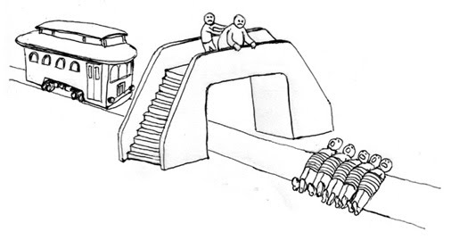

Fat man trolley problem. By push him you can save lifes. Don’t do anything 5 people will be killed. Push him you will save

[Kialo.com - Trolley Probme](https://www.kialo.com/the-trolley-problem-whats-the-right-solution-921?path=921.0~921.1)